Ideation Phase

Brainstorm & Idea Prioritization Worksheet

Date | 4 Aug 2026
Student ID | Navendhiran C
Project Name | Book a Doctor – Online Medical Appointment Platform
Maximum Marks | 4 Marks

Step 1: Team Formation & Problem Framing

TEAM FORMATION | PROBLEM STATEMENT  How can we build a platform that lets patients quickly discover, compare, and book appointments with the right doctors, while giving doctors and admin staff a straightforward way to manage schedules, verifications, and medical records — all inside one secure system? | PROBLEM SELECTED

Step 2: Brainstorming — Idea Capture & Clustering

Core Booking Flow
Security & Roles
Patient Experience

Search & filter doctors
Live availability & scheduling
Booking history / reschedule

Role-based login (JWT)
Password encryption (bcrypt)
Doctor credential verification

Doctor profiles with ratings
Notifications
In-app chat
Reviews & feedback

Records & Compliance
Video consultation
Integrated payment gateway

Future Enhancements

Secure document upload
Storage for prescriptions & reports

Step 3: Idea Prioritization (Importance vs Feasibility)
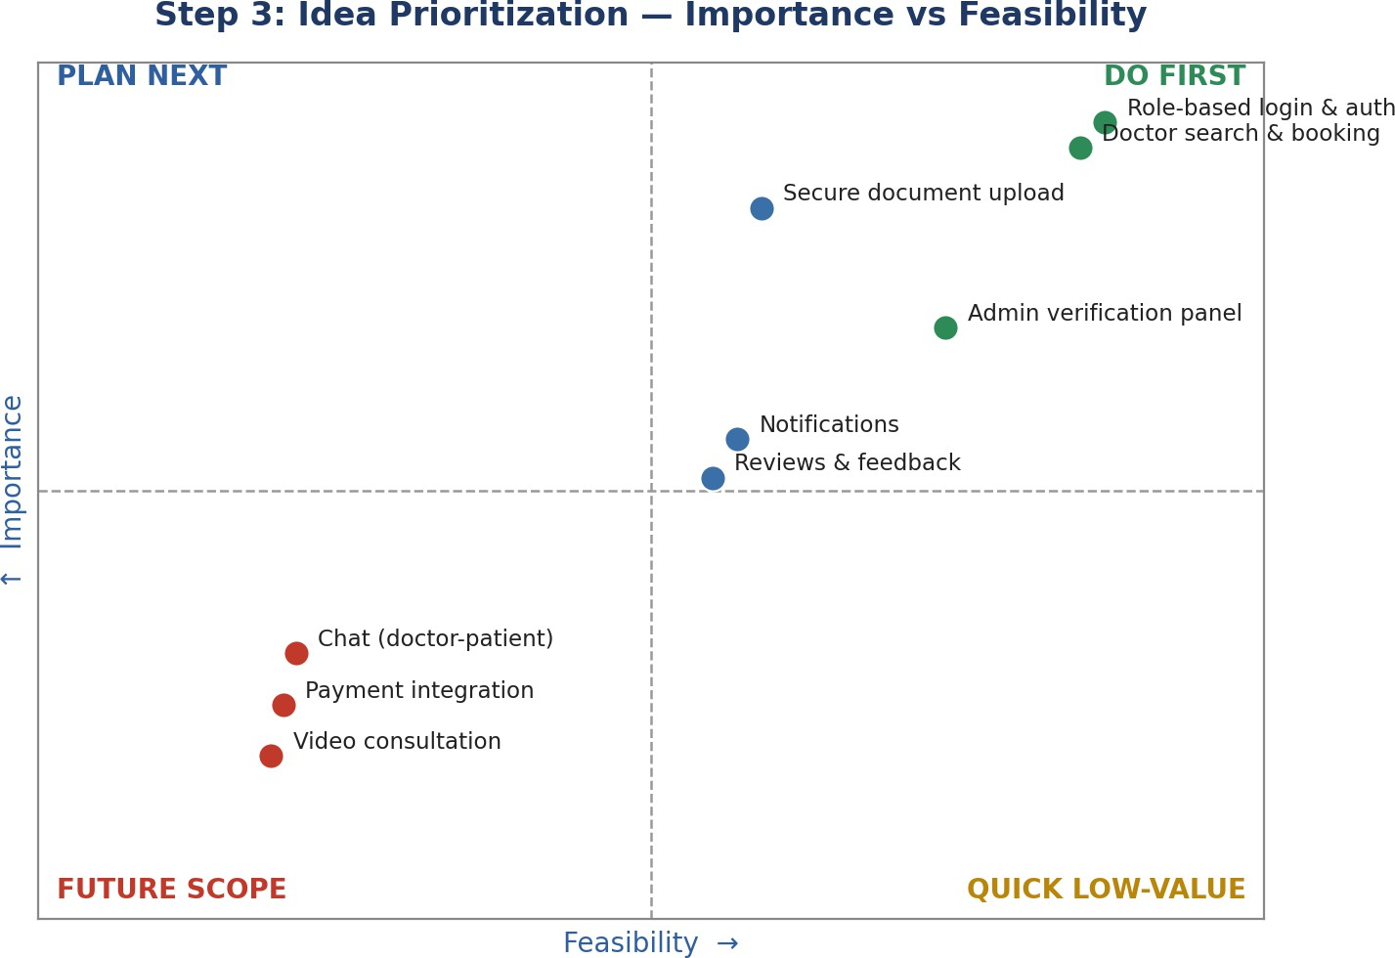

Conclusion
The items rated high on both importance and feasibility — authentication, doctor search and booking, and admin verification — make up the MVP core and were placed in the Do First quadrant. Secure document upload, notifications, and reviews were grouped as Plan Next, supporting features to layer in once the core flow is stable. Chat, video consultation, and payment integration were pushed to Future Scope, since they extend beyond what this capstone phase needs to deliver.

